Constructing Dart

Definition
# Source: AI Source: Provided by: [Data Path: Persons Table -> ID Column: 1, Name_En Column: Motasem Essam] -> From: [ChatGPT] on [7/25/2026]
Constructing a Dart is the geometric construction of a dart-shaped quadrilateral using specified geometric information such as side lengths, diagonals, angles, or symmetry conditions, typically with a straightedge and compass.
A dart is a concave quadrilateral formed when one pair of adjacent sides extends inward, creating a reflex interior angle.
For dart $ABCD$, a common configuration has:
$$AB=AD$$
and
$$CB=CD$$
with one interior angle greater than ${180}^{∘}$.
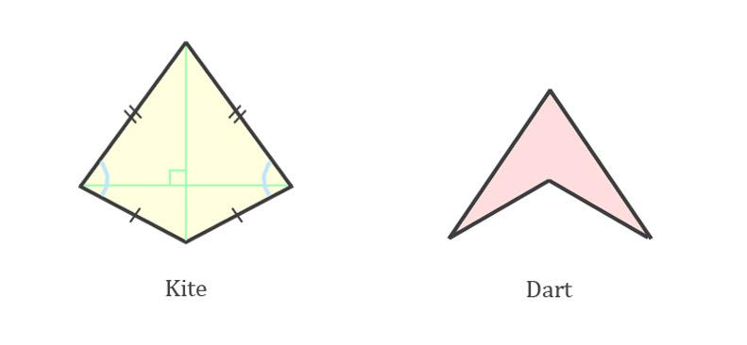
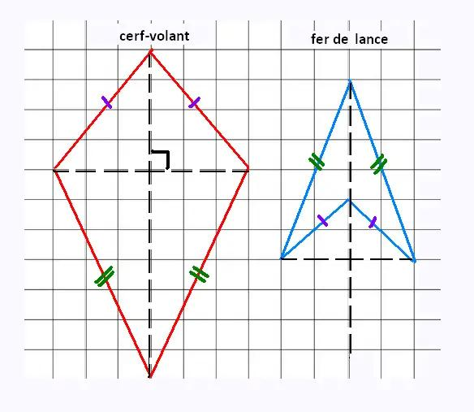
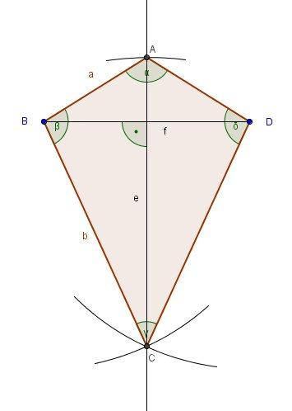

Fundamental Concept
# Source: AI Source: Provided by: [Data Path: Persons Table -> ID Column: 1, Name_En Column: Motasem Essam] -> From: [ChatGPT] on [7/25/2026]
A dart is closely related to a kite. In fact, a dart can be viewed as a concave kite when it has two pairs of adjacent equal sides.
The defining side relationships are commonly:
$$\boxed{AB=AD}$$
and
$$\boxed{BC=CD}$$
The difference is the shape:
- Kite: usually represented as a convex quadrilateral.
- Dart: concave quadrilateral with one reflex interior angle.
Thus:
$$\boxed{\text{Dart}=\text{Concave Quadrilateral with Kite-like Side Equality}}$$
Terminology note: "dart" is commonly used descriptively for a concave kite-shaped quadrilateral. It is not always treated as a separate fundamental quadrilateral class in every geometry classification system.

Main Construction – From a Diagonal and Two Side Lengths
# Source: AI Source: Provided by: [Data Path: Persons Table -> ID Column: 1, Name_En Column: Motasem Essam] -> From: [ChatGPT] on [7/25/2026]
Suppose we are given diagonal $AC$and the two distinct adjacent side lengths:
$$AB=AD=a \\ BC=CD=b$$
Construction Steps
- Construct the diagonal:
$$\overset{‾}{AC}$$
- Set the compass to length $a$.
- With center $A$, draw an arc on the required side of $AC$.
- Set the compass to length $b$.
- With center $C$, draw an arc intersecting the first arc at $B$.
- To create the dart configuration, choose the corresponding intersection $D$so that the quadrilateral becomes concave rather than convex.
- Connect:
$$A-B-C-D-A$$
- Verify:
$$AB=AD=a$$
and
$$BC=CD=b$$
The resulting quadrilateral is a dart when the chosen arrangement produces a concave vertex.

Construction From Three Given Vertices
# Source: AI Source: Provided by: [Data Path: Persons Table -> ID Column: 1, Name_En Column: Motasem Essam] -> From: [ChatGPT] on [7/25/2026]
If three vertices $A,B,C$are given, the fourth vertex $D$can be constructed using the required equal-side relationships.
For a dart satisfying:
$$DA=AB$$
and
$$DC=BC$$
Steps
- Given $A,B,C$.
- Set the compass to $AB$.
- Draw an arc centered at $A$.
- Set the compass to $BC$.
- Draw an arc centered at $C$.
- Their appropriate intersection gives $D$.
- Connect $A-D$and $C-D$.
Therefore:
$$DA=AB$$
and
$$DC=BC$$
The position of $D$determines whether the resulting quadrilateral is convex or concave. For a dart, select the intersection producing the concave configuration.

Construction From Two Pairs of Adjacent Equal Sides
# Source: AI Source: Provided by: [Data Path: Persons Table -> ID Column: 1, Name_En Column: Motasem Essam] -> From: [ChatGPT] on [7/25/2026]
Given:
$$AB=AD=a$$
and:
$$BC=CD=b$$
one can construct the dart by using the common diagonal $AC$.
Procedure
- Construct $AC$.
- Construct the locus of points at distance $a$from $A$.
- Construct the locus of points at distance $b$from $C$.
- Use their intersections to locate $B$and $D$.
- Select the configuration in which one vertex lies inside the corresponding convex hull, producing the concavity.
- Connect the four vertices.
The compass arcs effectively construct two pairs of equal distances.

Mathematical Properties
# Source: AI Source: Provided by: [Data Path: Persons Table -> ID Column: 1, Name_En Column: Motasem Essam] -> From: [ChatGPT] on [7/25/2026]
For a standard dart:
Adjacent Equal Sides
$$\boxed{AB=AD} \\ \boxed{BC=CD}$$
One Reflex Angle
A dart has one interior angle greater than ${180}^{∘}$:
$$\boxed{{180}^{∘}<θ<{360}^{∘}}$$
The remaining three interior angles are less than ${180}^{∘}$.
Interior Angle Sum
Like every simple quadrilateral:
$$\boxed{\sum{θ}={360}^{∘}}$$
This remains true even though one angle is reflex.
Diagonals
The diagonal joining the vertices where the equal-side pairs meet is:
$$\overset{‾}{AC}$$
In the standard symmetric dart, $AC$is an axis of symmetry and is perpendicular to the other diagonal:
$$\boxed{AC⊥BD}$$
It also bisects $BD$:
$$\boxed{BO=OD}$$
where $O$is the intersection of the diagonals.

Area
# Source: AI Source: Provided by: [Data Path: Persons Table -> ID Column: 1, Name_En Column: Motasem Essam] -> From: [ChatGPT] on [7/25/2026]
For a dart with perpendicular diagonals, the magnitude of its area can be calculated using:
$$\boxed{A=\frac{d_{1}d_{2}}{2}}$$
where $d_{1}$and $d_{2}$are the diagonal lengths.
Because the dart is concave, the signed-area interpretation depends on the vertex ordering, but its ordinary geometric area is positive.

Perimeter
# Source: AI Source: Provided by: [Data Path: Persons Table -> ID Column: 1, Name_En Column: Motasem Essam] -> From: [ChatGPT] on [7/25/2026]
If the two pairs of adjacent equal sides have lengths $a$and $b$:
$$\boxed{P=2\left(a+b\right)}$$
For example, if:
$$AB=AD=5\text{ cm}$$
and:
$$BC=CD=3\text{ cm}$$
then:
$$P=2\left(5+3\right)=16\text{ cm}$$

Types / Construction Situations
# Source: AI Source: Provided by: [Data Path: Persons Table -> ID Column: 1, Name_En Column: Motasem Essam] -> From: [ChatGPT] on [7/25/2026]
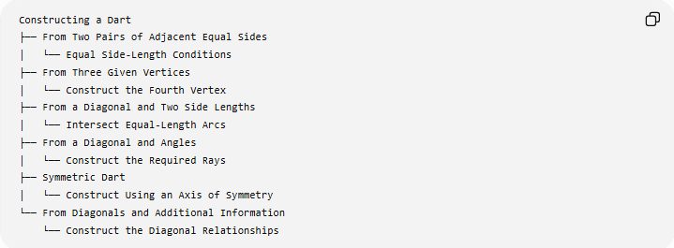
Constructing a Dart
├── From Two Pairs of Adjacent Equal Sides
│ └── Equal Side-Length Conditions
├── From Three Given Vertices
│ └── Construct the Fourth Vertex
├── From a Diagonal and Two Side Lengths
│ └── Intersect Equal-Length Arcs
├── From a Diagonal and Angles
│ └── Construct the Required Rays
├── Symmetric Dart
│ └── Construct Using an Axis of Symmetry
└── From Diagonals and Additional Information
└── Construct the Diagonal Relationships
These are construction situations, rather than universally standardized mathematical "types" of darts.

Dart vs Kite
# Source: AI Source: Provided by: [Data Path: Persons Table -> ID Column: 1, Name_En Column: Motasem Essam] -> From: [ChatGPT] on [7/25/2026]
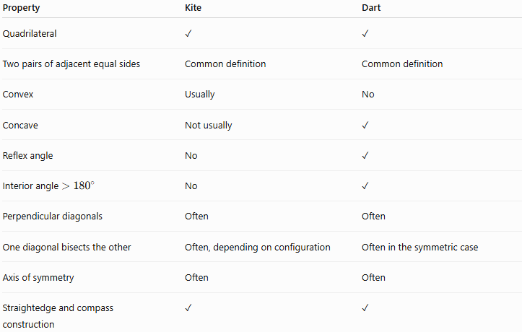
Property | Kite | Dart
Quadrilateral | ✓ | ✓
Two pairs of adjacent equal sides | Common definition | Common definition
Convex | Usually | No
Concave | Not usually | ✓
Reflex angle | No | ✓
Interior angle $>{180}^{∘}$ | No | ✓
Perpendicular diagonals | Often | Often
One diagonal bisects the other | Often, depending on configuration | Often in the symmetric case
Axis of symmetry | Often | Often
Straightedge and compass construction | ✓ | ✓
The essential geometric distinction is convexity versus concavity, rather than the equal-side relationships alone.

Dart vs Other Quadrilaterals
# Source: AI Source: Provided by: [Data Path: Persons Table -> ID Column: 1, Name_En Column: Motasem Essam] -> From: [ChatGPT] on [7/25/2026]
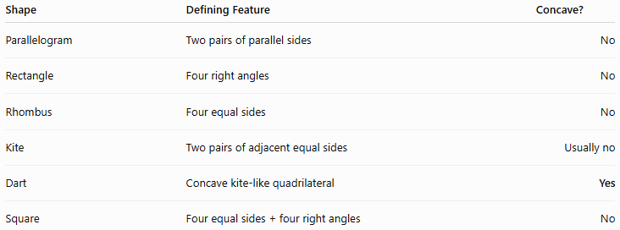
Shape | Defining Feature | Concave?
Parallelogram | Two pairs of parallel sides | No
Rectangle | Four right angles | No
Rhombus | Four equal sides | No
Kite | Two pairs of adjacent equal sides | Usually no
Dart | Concave kite-like quadrilateral | Yes
Square | Four equal sides + four right angles | No

Basic Constructions Used
# Source: AI Source: Provided by: [Data Path: Persons Table -> ID Column: 1, Name_En Column: Motasem Essam] -> From: [ChatGPT] on [7/25/2026]
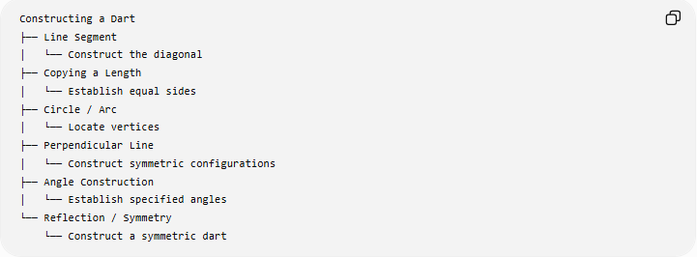
Constructing a dart can involve:
Constructing a Dart
├── Line Segment
│ └── Construct the diagonal
├── Copying a Length
│ └── Establish equal sides
├── Circle / Arc
│ └── Locate vertices
├── Perpendicular Line
│ └── Construct symmetric configurations
├── Angle Construction
│ └── Establish specified angles
└── Reflection / Symmetry
└── Construct a symmetric dart

Classification
# Source: AI Source: Provided by: [Data Path: Persons Table -> ID Column: 1, Name_En Column: Motasem Essam] -> From: [ChatGPT] on [7/25/2026]
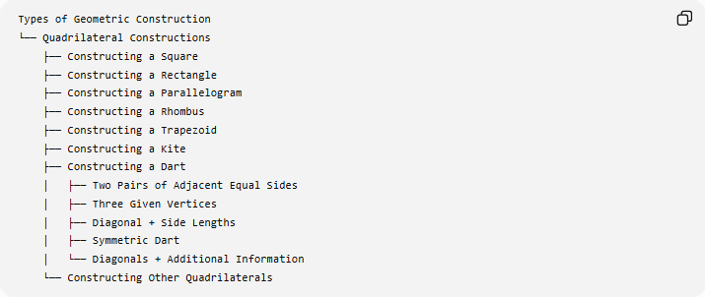
Types of Geometric Construction
└── Quadrilateral Constructions
├── Constructing a Square
├── Constructing a Rectangle
├── Constructing a Parallelogram
├── Constructing a Rhombus
├── Constructing a Trapezoid
├── Constructing a Kite
├── Constructing a Dart
│ ├── Two Pairs of Adjacent Equal Sides
│ ├── Three Given Vertices
│ ├── Diagonal + Side Lengths
│ ├── Symmetric Dart
│ └── Diagonals + Additional Information
└── Constructing Other Quadrilaterals

Key Points
# Source: AI Source: Provided by: [Data Path: Persons Table -> ID Column: 1, Name_En Column: Motasem Essam] -> From: [ChatGPT] on [7/25/2026]
- A dart is a concave quadrilateral with a characteristic inward-pointing vertex.
- It is commonly treated as a concave kite.
- A standard dart has two pairs of adjacent equal sides:
$$AB=AD, BC=CD$$
- It has one reflex interior angle.
- Its interior angles still sum to:
$${360}^{∘}$$
- In a symmetric dart, one diagonal acts as an axis of symmetry.
- The diagonals are perpendicular in the standard symmetric configuration.
- Straightedge and compass constructions use segments, arcs, copied lengths, perpendiculars, and angles.
- Construction categories such as "from three vertices" or "from a diagonal" describe given-information cases, not fundamental mathematical types of darts.

Conclusion
# Source: AI Source: Provided by: [Data Path: Persons Table -> ID Column: 1, Name_En Column: Motasem Essam] -> From: [ChatGPT] on [7/25/2026]
Constructing a Dart is the exact geometric construction of a concave quadrilateral, commonly characterized by two pairs of adjacent equal sides. The construction can be performed from given side lengths, vertices, diagonals, angles, or symmetry information using straightedge and compass. The central challenge is not merely establishing the equal-side relationships, but selecting the appropriate vertex configuration so that the resulting quadrilateral is concave, giving the dart its characteristic shape.

